Georgia Governor Eugene Talmadge
(1884-1946)
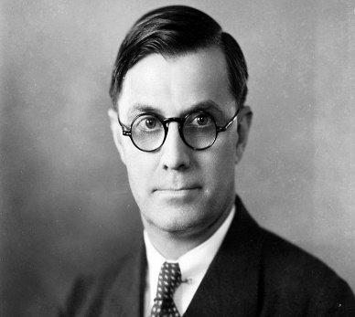
Eugene Talmadge was born on the family farm near Forsyth, Georgia on September 23, 1884, to Carrie Roberts and Thomas R. Talmadge. After attending the University of Georgia and briefly teaching, Talmadge returned to Athens to earn a law degree, graduating in1907. He practiced law briefly in Atlanta before moving to Ailey and then Mt. Vernon to start his own practice. In 1909, he married Mattie Thurmond Peterson, a young widow, who was the telegraph operator in Ailey. They had three children: Margaret, Vera, and Herman Eugene. The Talmadges later moved to a farm in Telfair County.
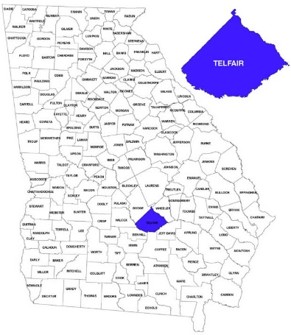
After holding minor offices in Telfair County, Talmadge made unsuccessful runs for state legislative office in 1920 and 1922. A member of the Democratic Party, he finally won state elective office by defeating Commissioner of Agriculture J. J. Brown in 1926. Talmadge was overwhelmingly reelected in 1928 and 1930. He used the department's newspaper, the Market Bulletin, to give advice to farmers on how to improve their farming skills and operations. But more important, Talmadge used the Bulletin to express his views on political issues and to present himself as an outspoken advocate for the farmers.
Six years later he was elected governor of Georgia. Talmadge's main support came from white farmers and his right wing views earned him the name, the "Wild Man from Sugar Creek". Once in power Talmadge dramatically cut budgets resulting in massive reductions in state services. He also helped local businessmen in their opposition to trade unions.
Talmadge was an outspoken opponent of President Franklin Roosevelt and his New Deal policies that he described as a combination of wet nursing, frenzied finance, downright Communism and plain [darn] foolishness." He also controversially claimed that the Civilian Conservation Corps (CCC) were "bums and loafers." He also disliked what he considered to be Roosevelt's pro trade union legislation such as the National Labour Relations Act . When a textile strike broke out in 1934, Talmadge declared martial law and sent troops to deal with strikers.
Talmadge was also opposed to black civil rights and in 1941 attempted to fire two University System administrators, allegedly for advocating integrated public schools. When the Board of Regents refused, Talmadge dismissed all of them and replaced them with people amenable to his will. This led to ten Georgia public colleges and universities losing their accreditation.
Talmadge was elected as governor of Georgia in 1932, 1934, 1940 and again in 1946. However, he was in poor health and died before he could take office [in1946]. He was now replaced by his son, Herman Talmadge, as governor of Georgia.

Historical Person/Group Analysis
Background  - When were they born?  - When did they die?  - Where were they born?  - Who were their parents?  - Were they married?  - Did they have any children?  - How much education did they have?  - What type of career or job did they have? | Beliefs  - What ideas or beliefs were important to them?  - What life experiences shaped their beliefs?  - What groups or people were they for?  - What groups or people were they against? | Impact  - How did they influence the citizens of Georgia?  - What were some of the ways in which they impacted the state?  - What was their overall impact, positive or negative, on the citizens or state?
IMPACT
IMPACT

BACKGROUND
IMPACT
IMPACT
BELIEFS

